Birla Institute of Technology and Science, Pilani

Second Semester 2008-2009

AAOC C321: Control Systems

Comprehensive Examination(Closed Book)

Date: 04.05.2009 Time: 3 Hrs MM: 120
Q.1 Consider the system given in Fig. Q.1(a). The torque speed characteristic of 2-phase ac servomotor with 50 V applied to control winding is given in Fig. Q.1(b). The various parameters of this system are given below.
Amplifier gain (K_{A}) = 10 V/V; synchro pair sensitivity (K_{s}) = 5 V/rad
Tachometer constant (K_{t}) = 0.2 V/rad/s
Moment of inertia of the motor is 0.05 kg-m² and friction coefficient is 0.01 Nm/rad/s
Moment of inertia of the load is 0.5 kg-m² and friction coefficient is 0.1 Nm/rad/s
Gear reduction ratio: 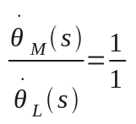 , 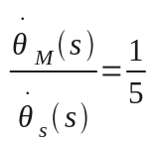 and 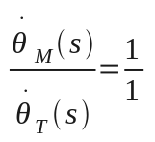
For this System
(a) Draw the block diagram
(b) Find the transfer function θ_{L} (s)/ θ_{r} (s)
(c) Determine the sensitivity with respect to sudden changes in amplifier gain K_{A} at DC frequency.
[20]
5

T (Nm)

500
Speed (rad/s)

Fig Q. 1(b)
50 V

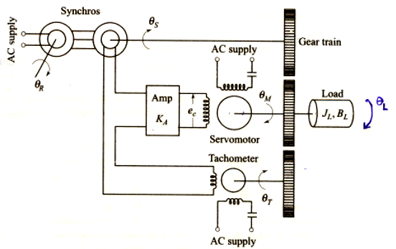
Fig Q.1 (a)
Q.2 For the system shown below, design a suitable compensator using Bode’s magnitude (asymptotic) and phase plots to meet the following specifications
(a) Steady state error for a ramp input is ≤ 0.1 unit
(b) Gain margin is always ≥ 12 db and
- Phase margin is 60°, take margin of safety as 12°.
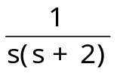
Also draw the Bode plots for overall system including compensator.
K
R(s)
+
Compensator
PTO
C(s)
Semi-log graph sheet is provided for the same. [25]
Q.3 Sketch the Nyquist plot for a system whose open loop transfer function is 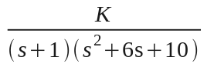, choosing the appropriate Nyquist contour. Determine the range of K for which the closed loop system is stable. [25]

Q.4 (a) For the liquid level control system shown below,

- Write down the governing differential equations
- Draw the signal flow graph and therefrom determine the transfer function 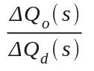 and 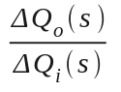using Mason’s gain formula.
C_{1,} C₂ and C are the capacities of respective tanks.

Q+ΔQ_{i}
ΔQ_{d}
C₁
C₂

Q₂+ΔQ₂
R₁
H₁+ΔH₁
H₂+ΔH₂
R₂
R
H+ΔH
Q₁+ΔQ₁
C
Fig Q.4

Q+ΔQ_{o}

(b) The transfer function of a system is 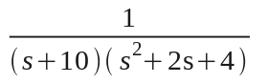.Using the concept of dominant pole pair, reduce the system to second order and then determine the time at first undershoot. [20+5]

Q.5 The block diagram of a control system is shown in Fig. Q.5. For this system:
- Clearly sketch the region in K-α Plane that can be used without instability arising. (K and α are greater than zero).
- Determine the values of K and α so that the system’s damping ratio is 0.707 and its settling time is 1.5 sec for 5% tolerance band. Also sketch the real axis part of root locus.
- Draw the neat sketches of root contours for K=27.25 and 38.25, clearly showing the steps involved. [7+8+10]
C(s)
K
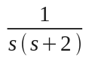
R(s)
+

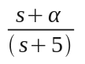

Fig Q.5

